DF ticketing System

Login Page:

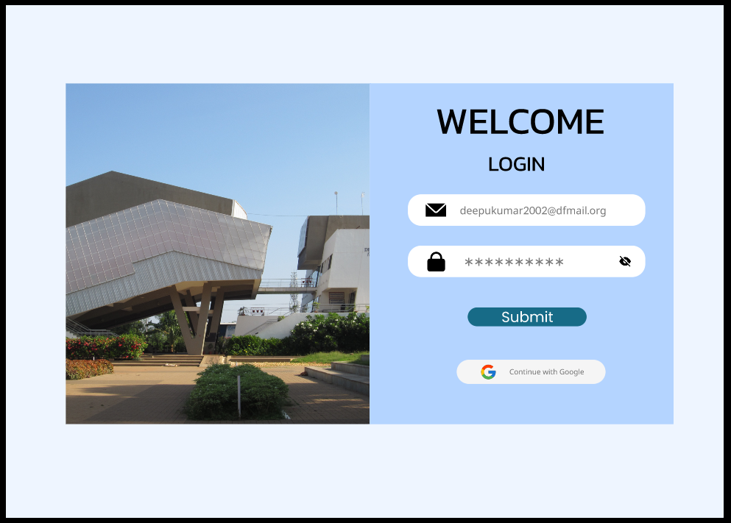

Onclick to “Submit” Button It will be followed to Home Page.

Home Page:

Click The Plus Icon To Open Report Page

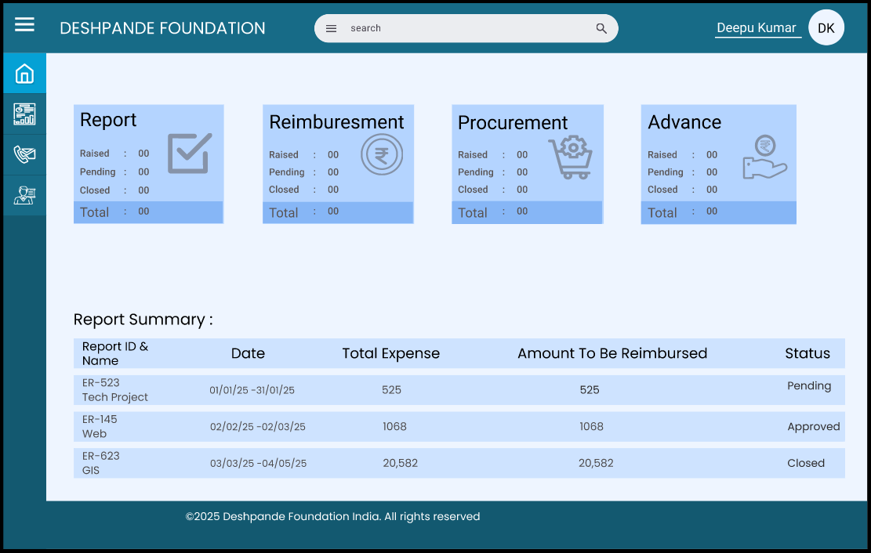

Manger’s

Page

Contact

Us

Report

Home

Profile

Onclick to “Report” Button It will be followed to Report page.

Task Page :

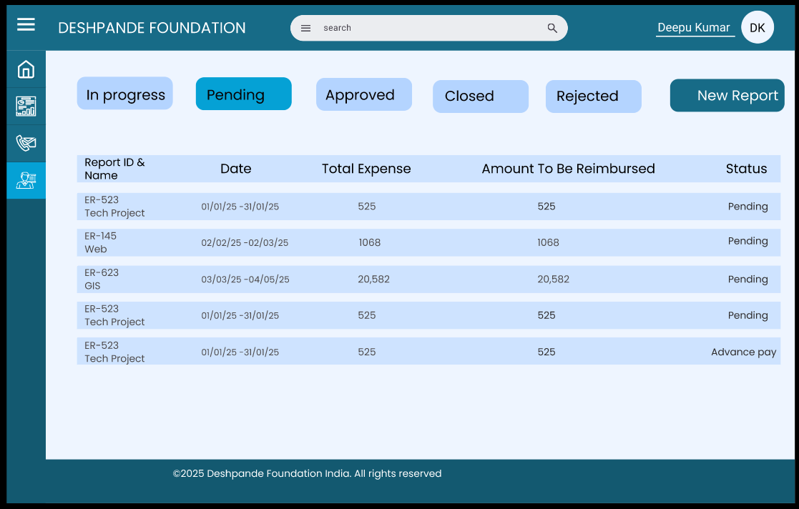

Onclick to “New Report” Button It will be followed to Report Popup.

Report Popup:

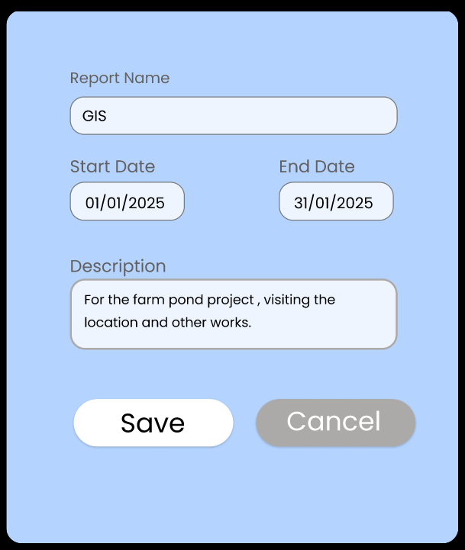

Onclick to “Save” Button It will be followed to Ticket Page.

Ticket Page:



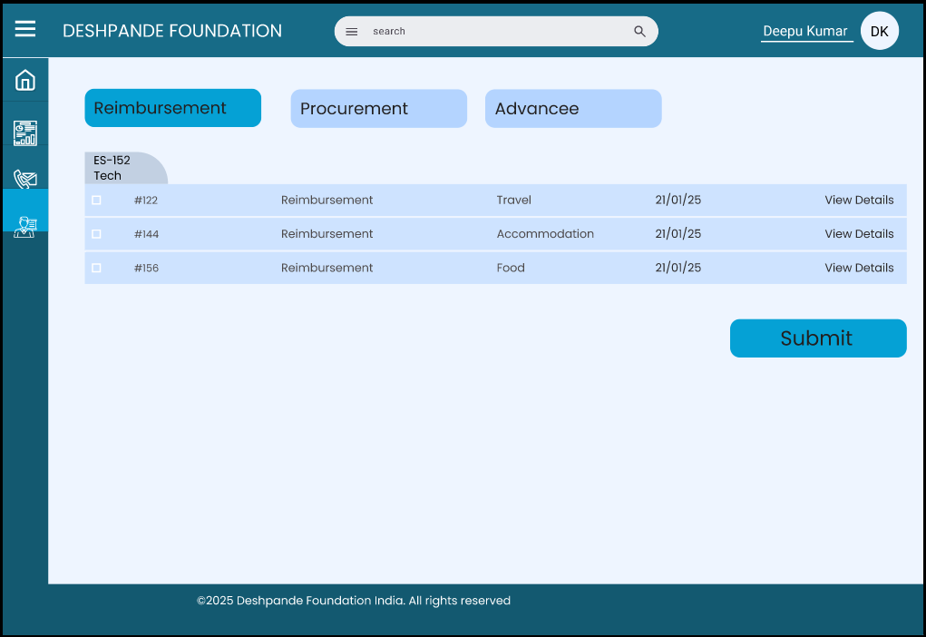



Types of ticket



Onclick to “Reimbursement” Button It will be followed to Reimbursement Ticket Page.

Reimbursement Ticket Popup:

* There Are Types Of Expense Category & Vehicle Type:
* 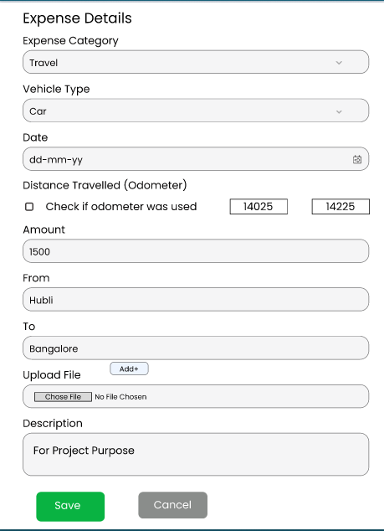Expense Type
* Travel
* Food
* Accommodation
* Vehicle Type
* Car
* Bus
* Bike
* Train
* Flight
* "Once you fill in all the details and click on the Save button, it will be saved in your report list."

Report List Page For Employee :



* Once You Save The Expense Details and It Create A Report According To Your report name

Eg: ES-152-Tech

* Once You Click on The Submit Button It Will Send to Manager for Approval

Manager Home Page :



Profile

Employee

Request list

Contact Us

Home

Report

* "Once you click on the Employee Request button, it will show all the raised tickets list."

Employee Request List Page:

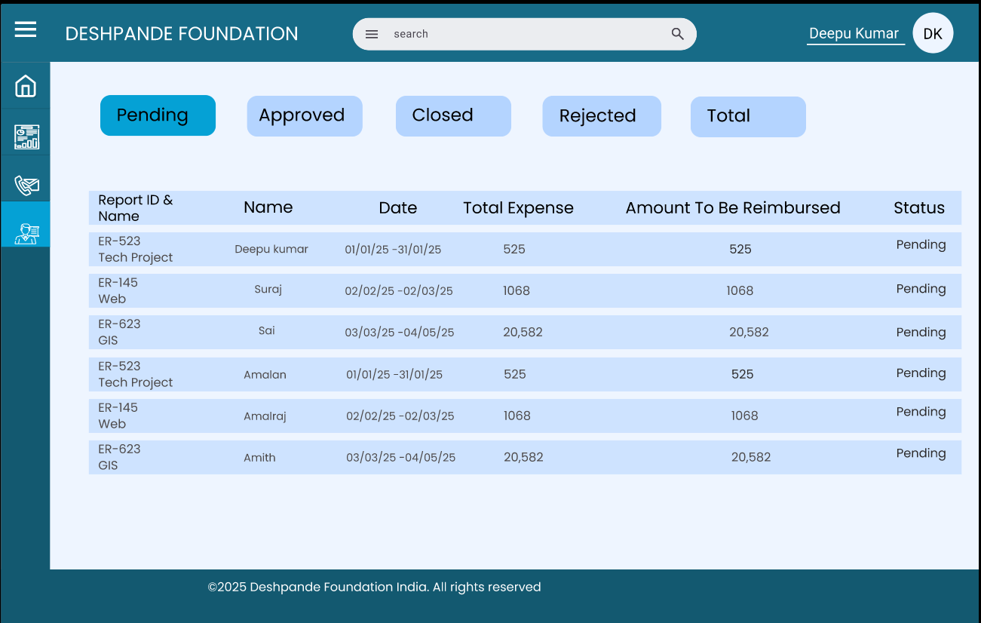

* "You can see different types of request reports, such as Pending, Approved, Closed, Rejected, and Total Reports. This helps you view the reports accordingly."
* "Click on the particular report to view the reimbursement request in detail."

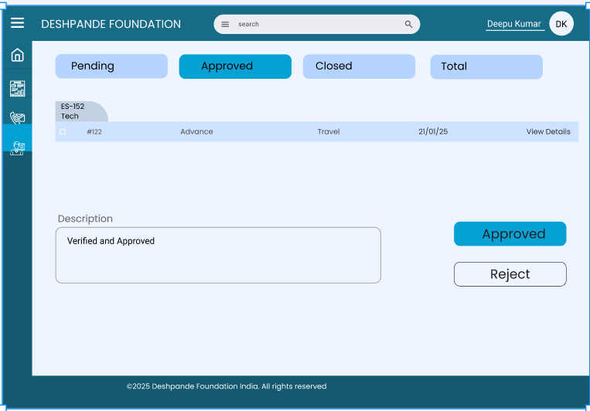Employee Request List Detail:

Report I’D &

Name

* "The manager can see the request list, and he can also view the details

by clicking on 'View Details.'"

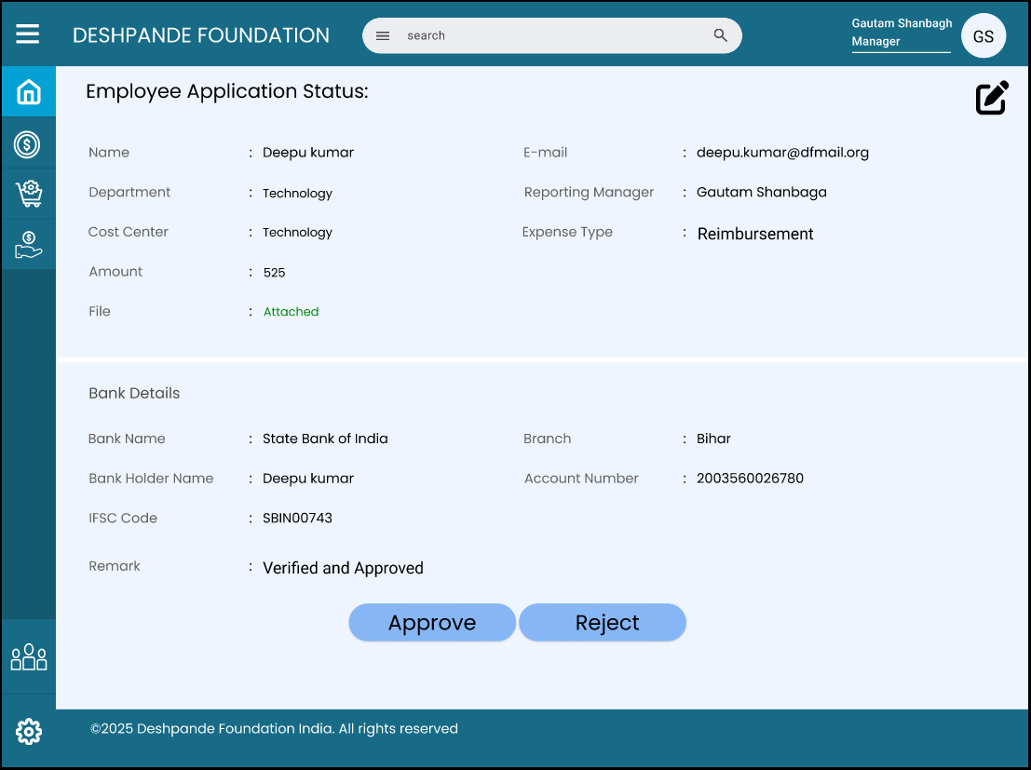

* Manager Can view Full Details Of Reimbursement And He can approve particular ticket
* Or Manager can approve Total report also

"Once the manager approves the report or ticket, it is directly sent to the finance team for review and to process the reimbursement payment."

Finance Team Home Page:

* In Finance team 2 types of process is there :
* "Finance processor – The finance processor can view the details and process the report."
* "Finance Approve – The finance team can approve the report based on the finance processor's review."

Profile

Report

Contact Us

Manager Approve list

Home

* "Once you click on the Manager Approve button, it will show all the approved reports."

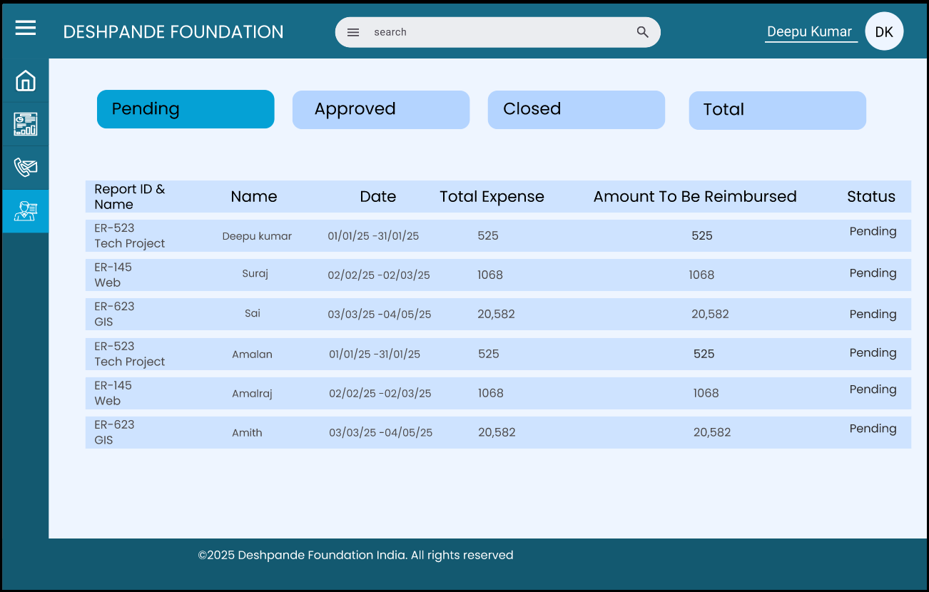

* "Once you click on a particular report, you can see the ticket list."

Manager Approved Report list:

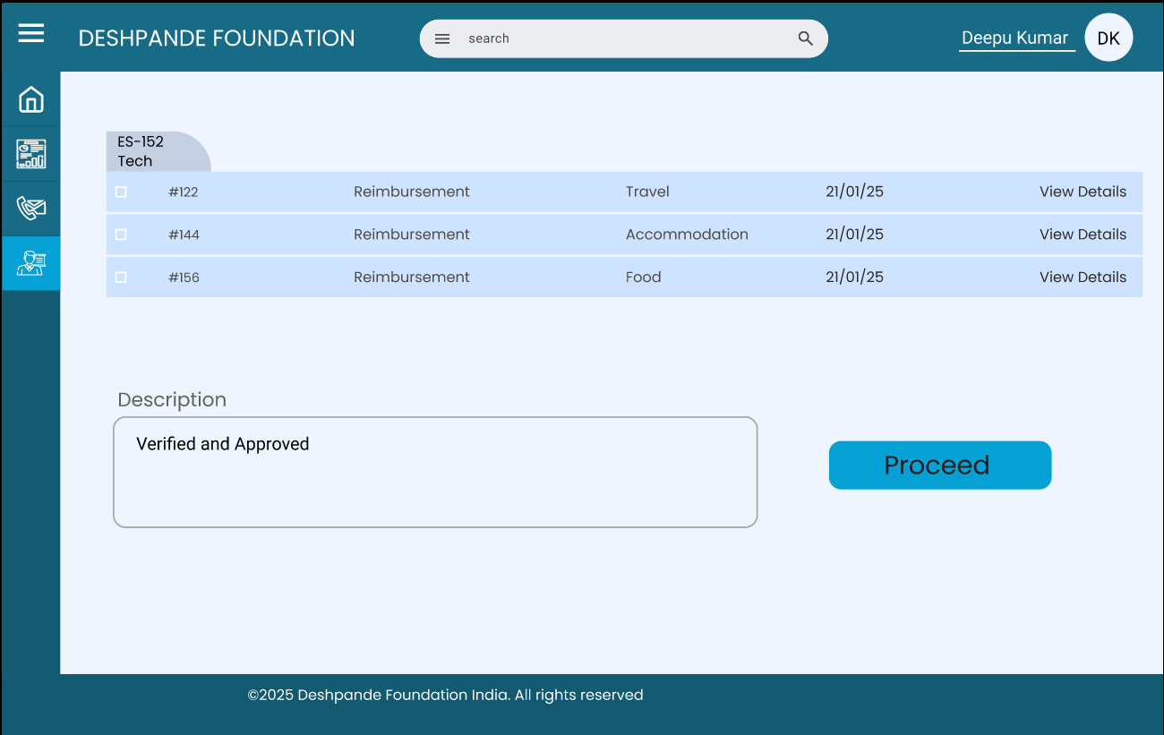

Report I’D &

Name

* "Click on the 'View Details' button so the finance team can

view the particular ticket list in detail."

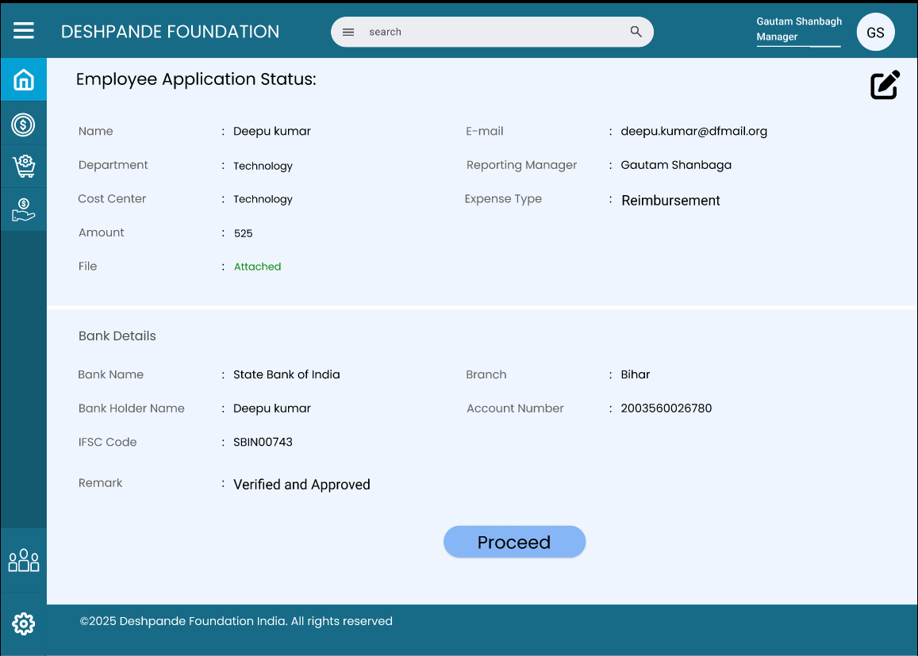

* "Click on the ‘edit button’ so the finance team can edit the ticket."
* "The finance processor can process the ticket or report. Once the finance processor processes the ticket, it is directly sent for finance approval.

Finance Approval page:



Profile

Finance process list

Contact Us

Report

Home

* "Once you click on the Finance Process button, it will show all the Process report list."
* "Once you click on a particular report, you can see the ticket list."

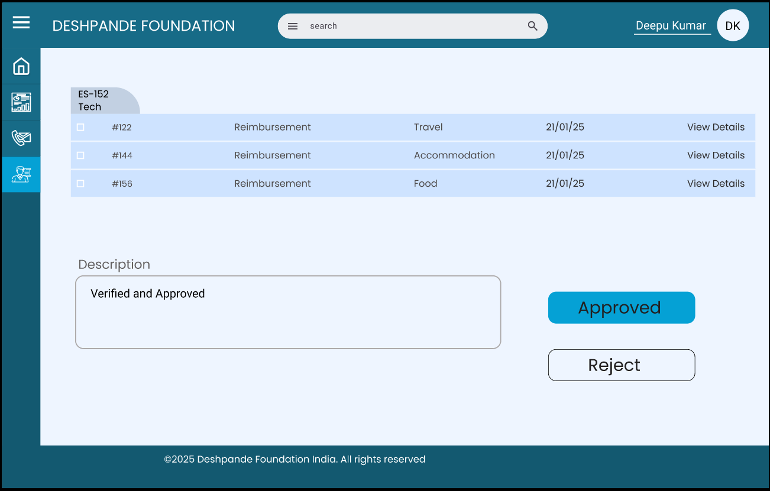

* "Click on the 'View Details' button so the finance team can

view the particular ticket list in detail."

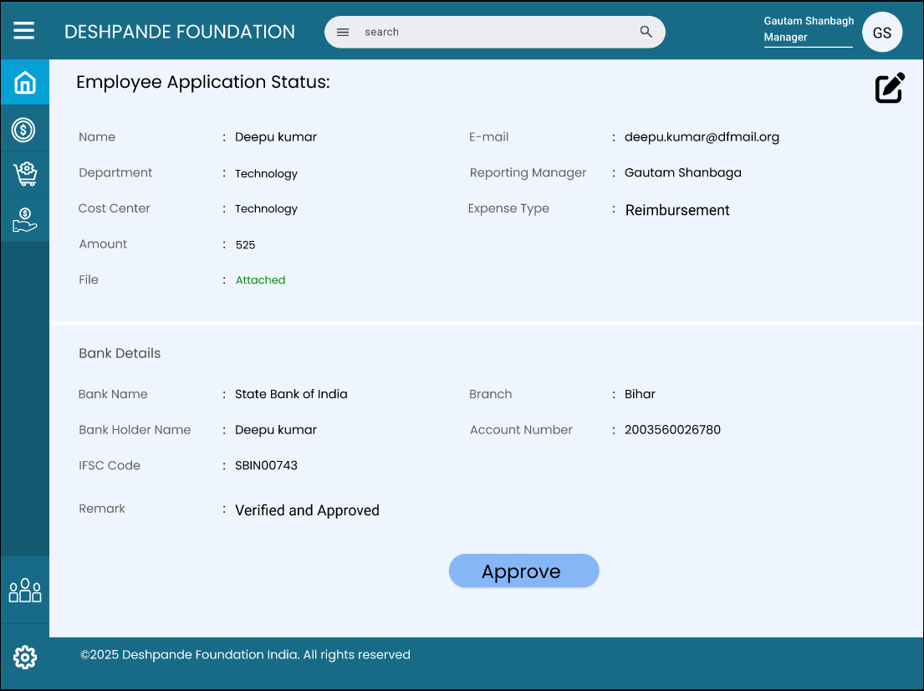

* "Click on the ‘edit button’ so the finance team can edit the ticket."

"The finance team can approve the ticket or report. Once the finance team approves the ticket, it is saved by the finance team until it is reimbursed."